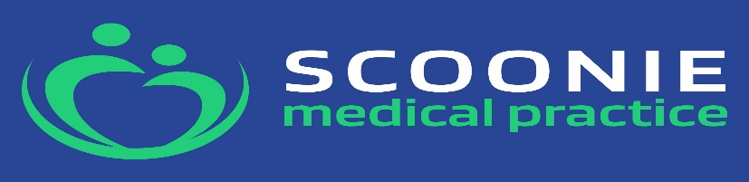

MEDICAL RECEPTIONIST
2 Posts
Post 1 27.5 hours per week 8.30am-2.00pm Monday-Friday
Post 2 37hrs per week (full time) 10.00am to 6.00pm Mon, Tues, Wed, Fri
10.00am-5.30pm Thurs
£26,411.99 - £27,395.32 per annum WTE (£13.69 - £14.20 per hour)
We are recruiting for 2 Medical Receptionists due to retirement and flexible working requests. You will join our friendly Practice Team. We are a large Practice of 12,800 patients, based in Leven Health Centre, Victoria Road, Leven KY8 4ET
The successful candidate will ;
- Work as part of a friendly supportive Team and be a Team player
- Enjoy contact with and assisting members of the public and health care professionals either on the phone or face to face
- Be an excellent communicator written and verbal
- Have a professional approach
- Work to protocol, training will be given
- Have good computer skills and willing to learn various IT systems
- Have an understanding of the data protection act and patient confidentiality
- Be able to work under pressure at times of high demand

Visit our news section on our website for a Job Description. Applications are welcome by CV detailing, reason for applying any other supporting information. PLEASE STATE THE POST YOU ARE APPLYING FOR POST 1 or POST 2
Email to Marion.Clacken@nhs.scot by Monday 18th^{th} May , closing date for applications 18th May
Follow our FB page for more information and updates on recruitment and visit our website www.scooniemedicalpractice.co.uk

